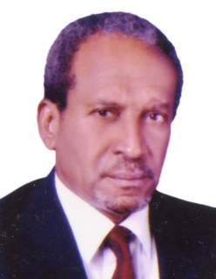
Sayed Ahmed Khalid Mohamed Zaroug
Address: United Arab Emirates
Mobile: +971 50 446 9165
Email: N/A

₊
Qualifications

Fellow Association of Chartered Certified Accountant (FCCA) – UK – 1970
B. Com – Cairo University – Sudan – 1963
Senior Diploma in Commerce – Khartoum Technical Institute – Sudan

Membership or Professional Associations

- Associate member of the Institute of Internal Auditors (USA)
- Associate member of the EDP Auditors Association (USA)
- U.A.E. Registered Certified Public Accountant under registration No. 460
- Enrolled as arbitrator and expert with the Abu Dhabi chamber of commerce and industry

Work Experience

A Chartered Certified Accountant with over 23 years extensive work experience in the Oil and Gas Industries within the ADNOC Group of companies in U.A.E. in senior executive capacities plus a few years home country experience in executive and advisory capacities. Had a wide exposure to a wide range of business environmental and processes arising from the performance of numerous Accounting, Financial and Internal audit assignments, and interaction with multi-national staff from the big international oil and gas companies. Involved as a team member of high caliber experts committee entrusted with the review and advising on the restructuring of Abu Dhabi women entities and Associations. Reviewed and prepared policies and procedure Manuals for Abu Dhabi Chamber of Commerce and Industry and the Private Building Departments.

Positions Held

- Partner of AGN MAK, a leading accounting and consultancy practice in U.A.E. providing professional services in Dubai, Sharjah, Jebel Ali, Muscat.
- Advisor Financial Policies & Procedure, Abu Dhabi Oil Refining Co, Takreer for 2 years.
- Head of International Audit Department, ADGAS, Abu Dhabi for 4 years.
- Head of Internal Audit Department, ADCO, Abu Dhabi for 3$\frac{1}{2}$ years.
- Senior Auditor with Ernst & Young Chartered Accountants, Abu Dhabi for 3 years.
- Finance Manager, Sudanese Kuwaiti Road Transport Company Ltd., Sudan
- Financial Controller and Deputy Director, Armed Forces Multi-Purpose Co-operative Corporation, Sudan
- Inspector / Assistant Registrar of Companies, Ministry of Commerce, Sudan

